**DATE:30-12-2024**

**NPS LAB-2**

**NAME:TATIKONDA SRI VENNELA**

**ROLL NO:2320030128**

**SEC-1**

**Step 1: Launch Cisco Packet Tracer**:

Double-click the Cisco Packet Tracer icon on your desktop or find it in your applications list to open the program.

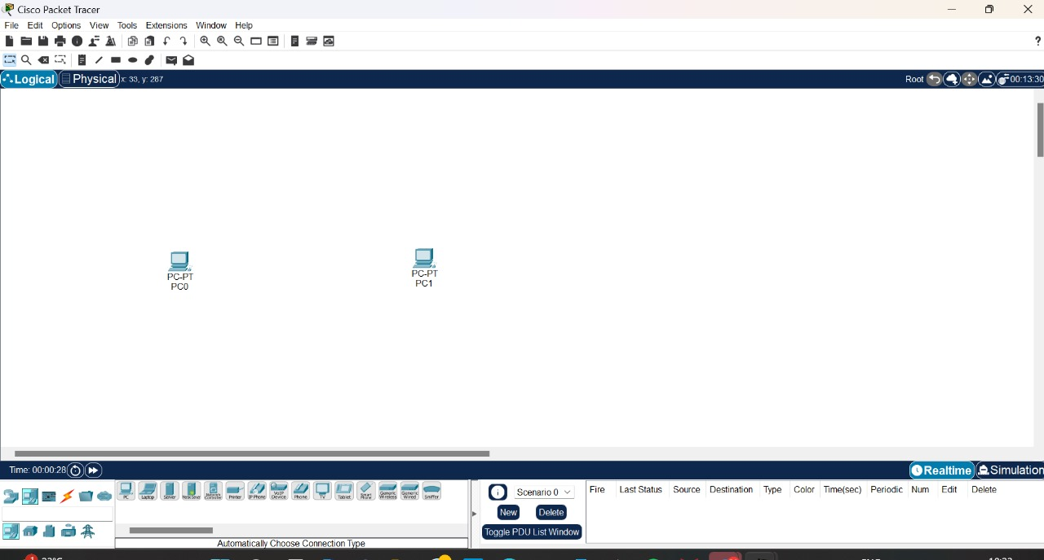

**Step 2: Create a Simple Network Topology**

**1. Add Devices**:

**o Routers and Switches**: Drag and drop a router and a switch from the device list onto the workspace.

**o PCs**: Drag and drop two PCs onto the workspace.

**2. Connect Devices**:

o Use the **Connection** tool to connect the devices:

- Connect one PC to the switch using a copper straight-through cable.

-Connect the switch to the router using another copper straight-through cable.

- Connect the second PC to the switch using a copper straight-through cable.

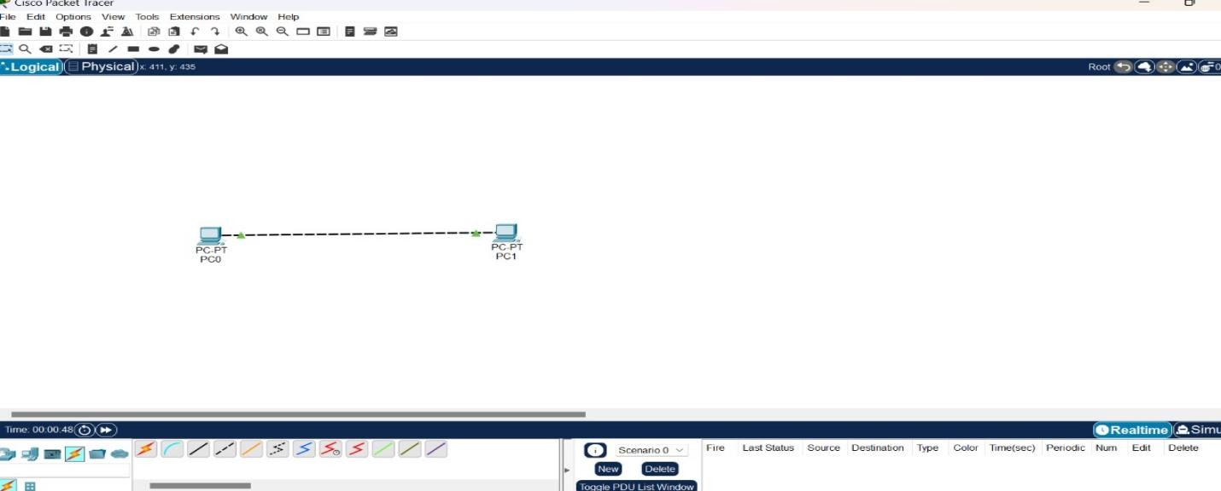

**Step 3: Configure Devices**

**1. Configure the Router**:

o Click on the router.

o Go to the **Config** tab.

o Assign IP addresses to the router interfaces.

o Example:

Interface G0/0: IP address 192.168.1.1, Subnet Mask 255.255.255.0

Interface G0/1: IP address 192.168.2.1, Subnet Mask 255.255.255.0

**2. Configure the PCs**:

o Click on each PC.

o Go to the **Desktop** tab and then **IP Configuration**.

o Assign IP addresses to each PC.

o Example:

PC0: IP address 192.168.1.2, Subnet Mask 255.255.255.0, Default Gateway 192.168.1.1

PC1: IP address 192.168.2.2, Subnet Mask 255.255.255.0, Default Gateway 192.168.2.1

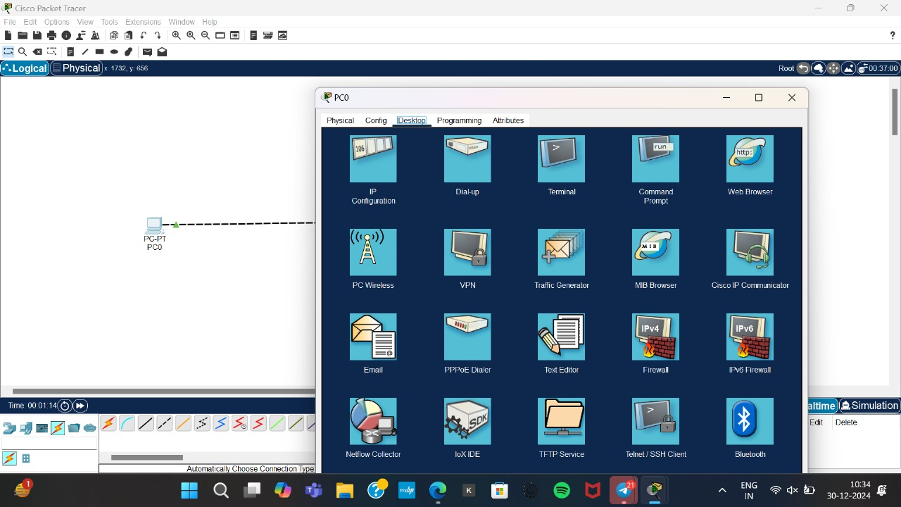

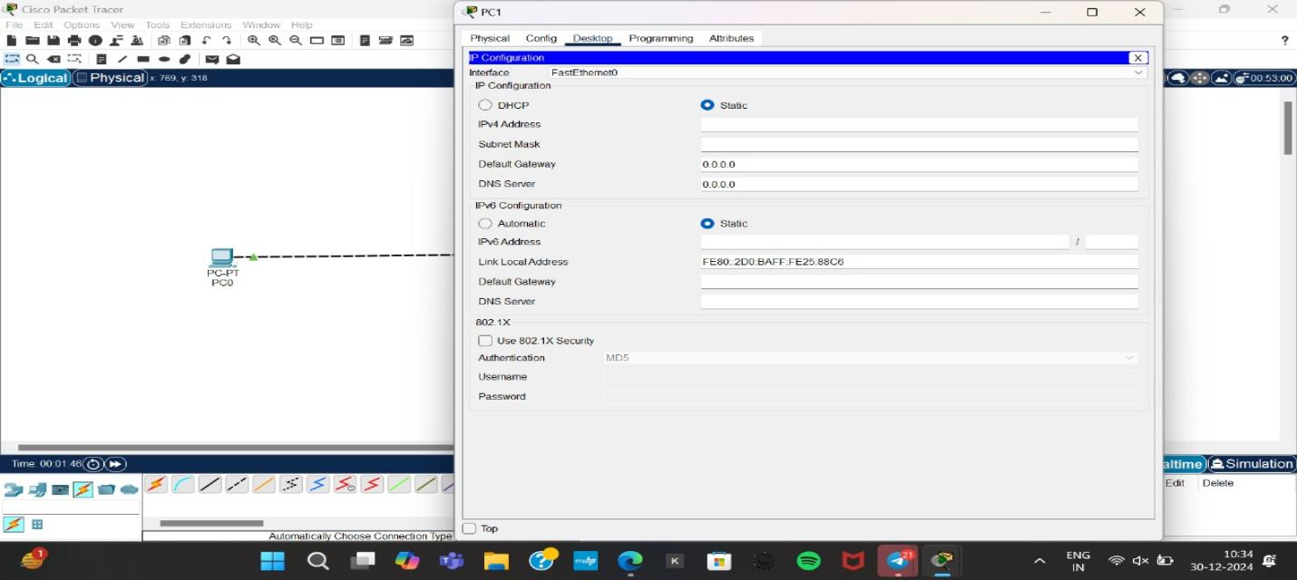

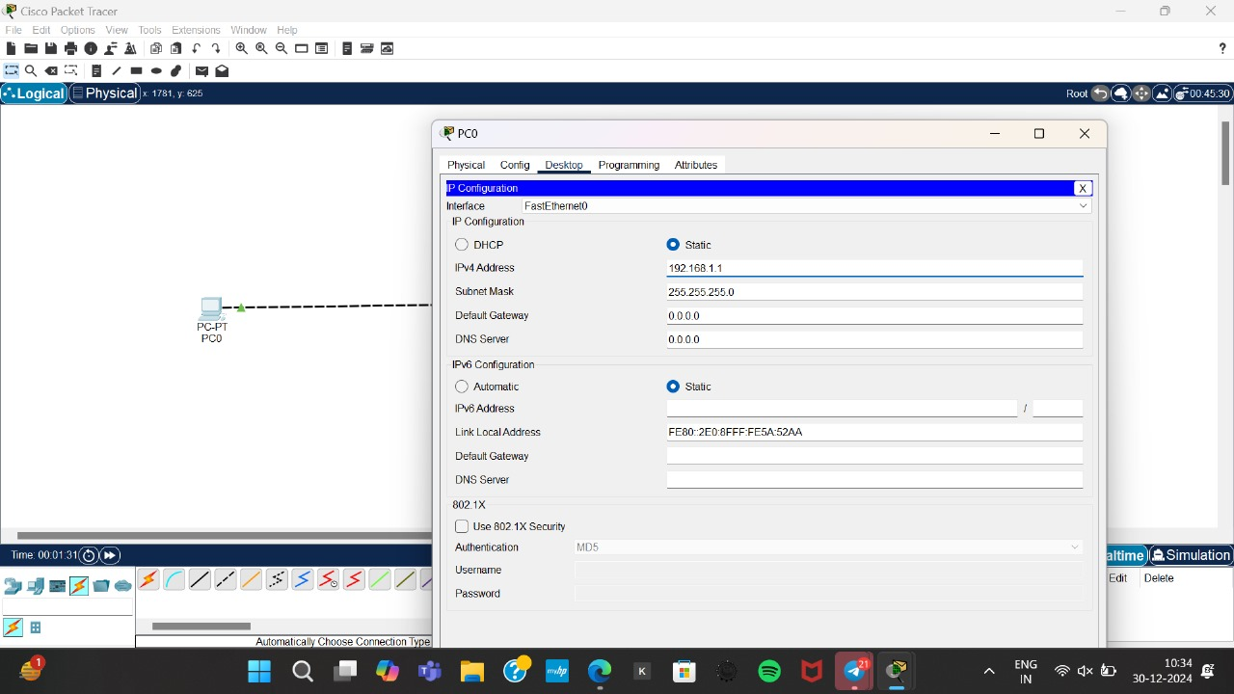

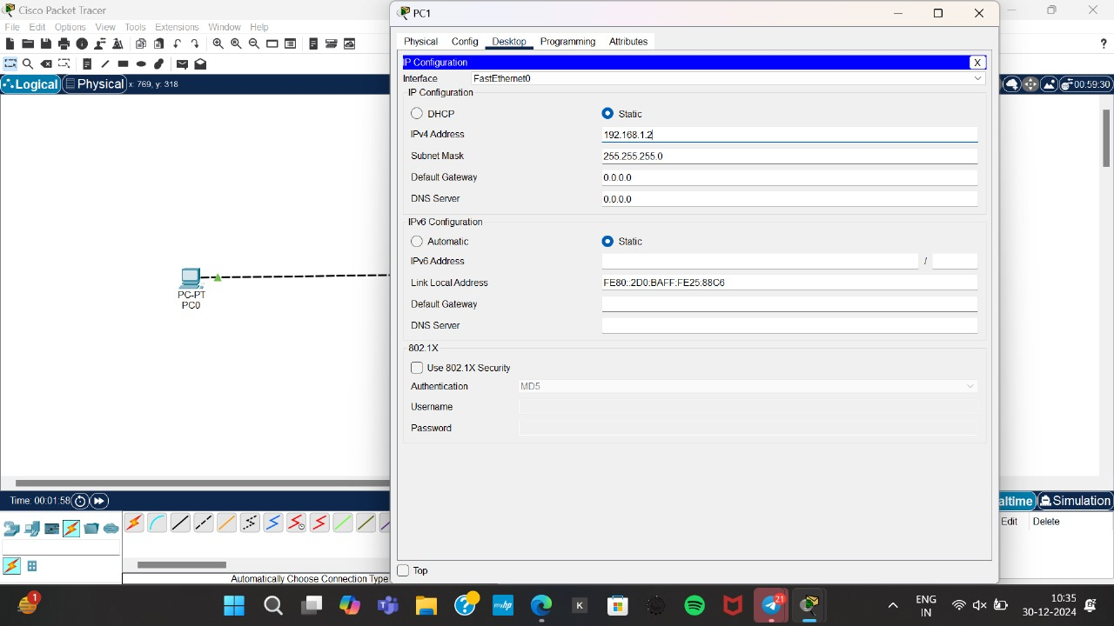

**Step 4: Execute Networking Commands**

**1. Open Command Prompt on a PC0**:

o Click on a PC0.

o Go to the **Desktop** tab and open the **Command Prompt**.

**1. ipconfig**:

This command displays all current TCP/IP network configuration values and refreshes DHCP and DNS settings.

